

**LAB Report**

**COURSE TITLE –** Microprocessor Lab

**COURSE CODE –** CSE 360

***Submitted To***

***Md. Ismail***

*Lecturer of UITS*

***Submitted By***

*Md. Shoyaif Rahman (****0432310005101050****)*

***Semester:*** *Autumn-2025 (6th)*

***Department:*** *CSE*

***Batch:*** *53*

***Section:****6A2*

Date: 27/08/25

Assembly Language Lab Report

# Lab report: 01

# Experiment Name: Input and Output Formatting in Assembly Language

## 1. Process

The purpose of this experiment is to:  
1. Take a character as input from the user.  
2. Print the character in different formats:  
 - On the same line  
 - On the same line with a tab  
 - On the same line with a space  
 - On a new line  
  
We use DOS interrupt 21h services in 8086 Assembly language to achieve this.

## 2. Implementation (Program Code – ASM)

1.print character in same line

org 100h

mov ah,1

int 21h

mov bl ,al

mov ah,2

mov dl, bl

int 21h

ret

**output:**

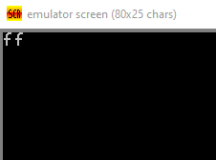

2.print character in same line with **tab**

org 100h

mov ah,1

int 21h

mov bl, al

mov ah,2

mov dl,009

int 21h

mov ah,2

mov dl, bl

int 21h

ret

**output:**

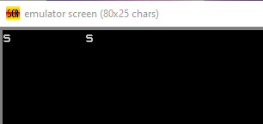

3.print character in same line with **space**

org 100h

mov ah,1

int 21h

mov bl ,al

mov ah,2

mov dl,010

int 21h

mov dl,013

int 21h

mov ah,2

mov dl, bl

int 21h

ret

**output:**

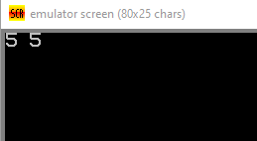

4. print character in **New line**

org 100h

mov ah,1

int 21h

mov bl, al

mov ah,2

mov dl,010

int 21h

mov dl,013

int 21h

mov ah,2

mov dl, bl

int 21h

ret

**output:**

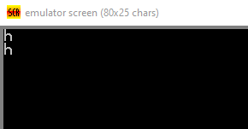

## 4. Conclusion

In this experiment, we successfully learned how to:  
- Take input from the user in Assembly language using INT 21h.  
- Print output on the same line, with tab, with space, and on a new line using INT 21h   
- This shows how formatting can be controlled using ASCII codes like 009 (Tab), 032(Space), and 010 (New Line), cret (013).